Step 1: Install Docker Desktop
- Verify docker
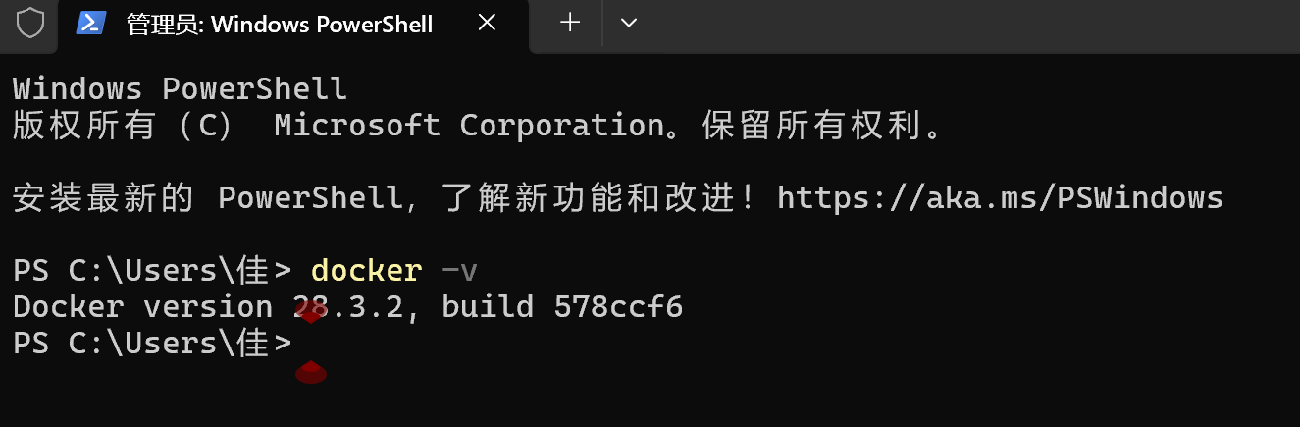
Step 2: Deploy Gitea with Docker
- Create a local data directory
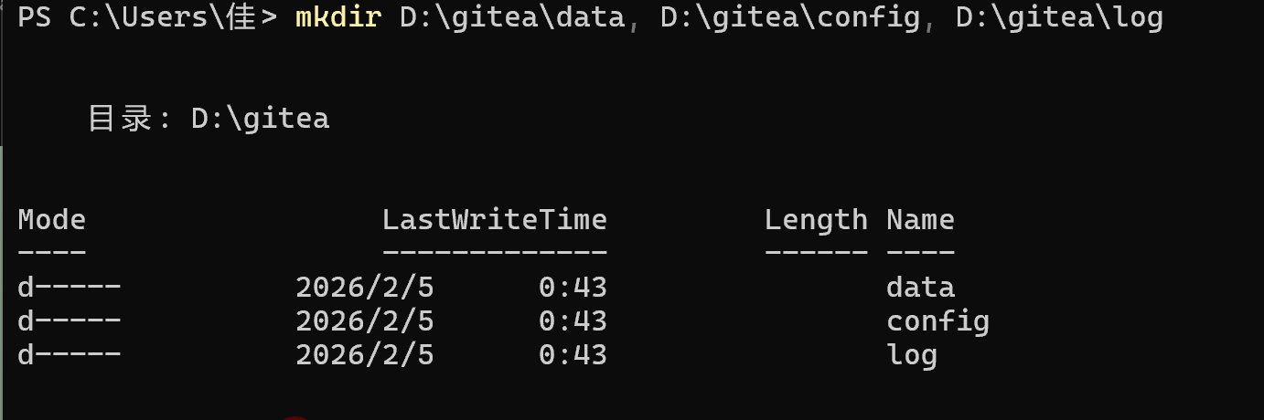
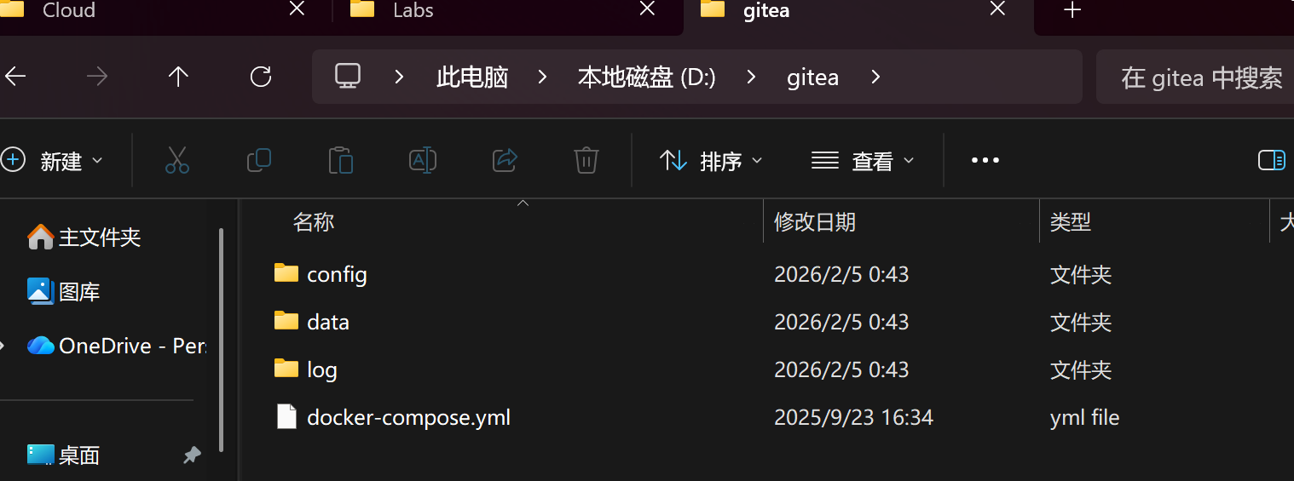
- Start the Gitea container
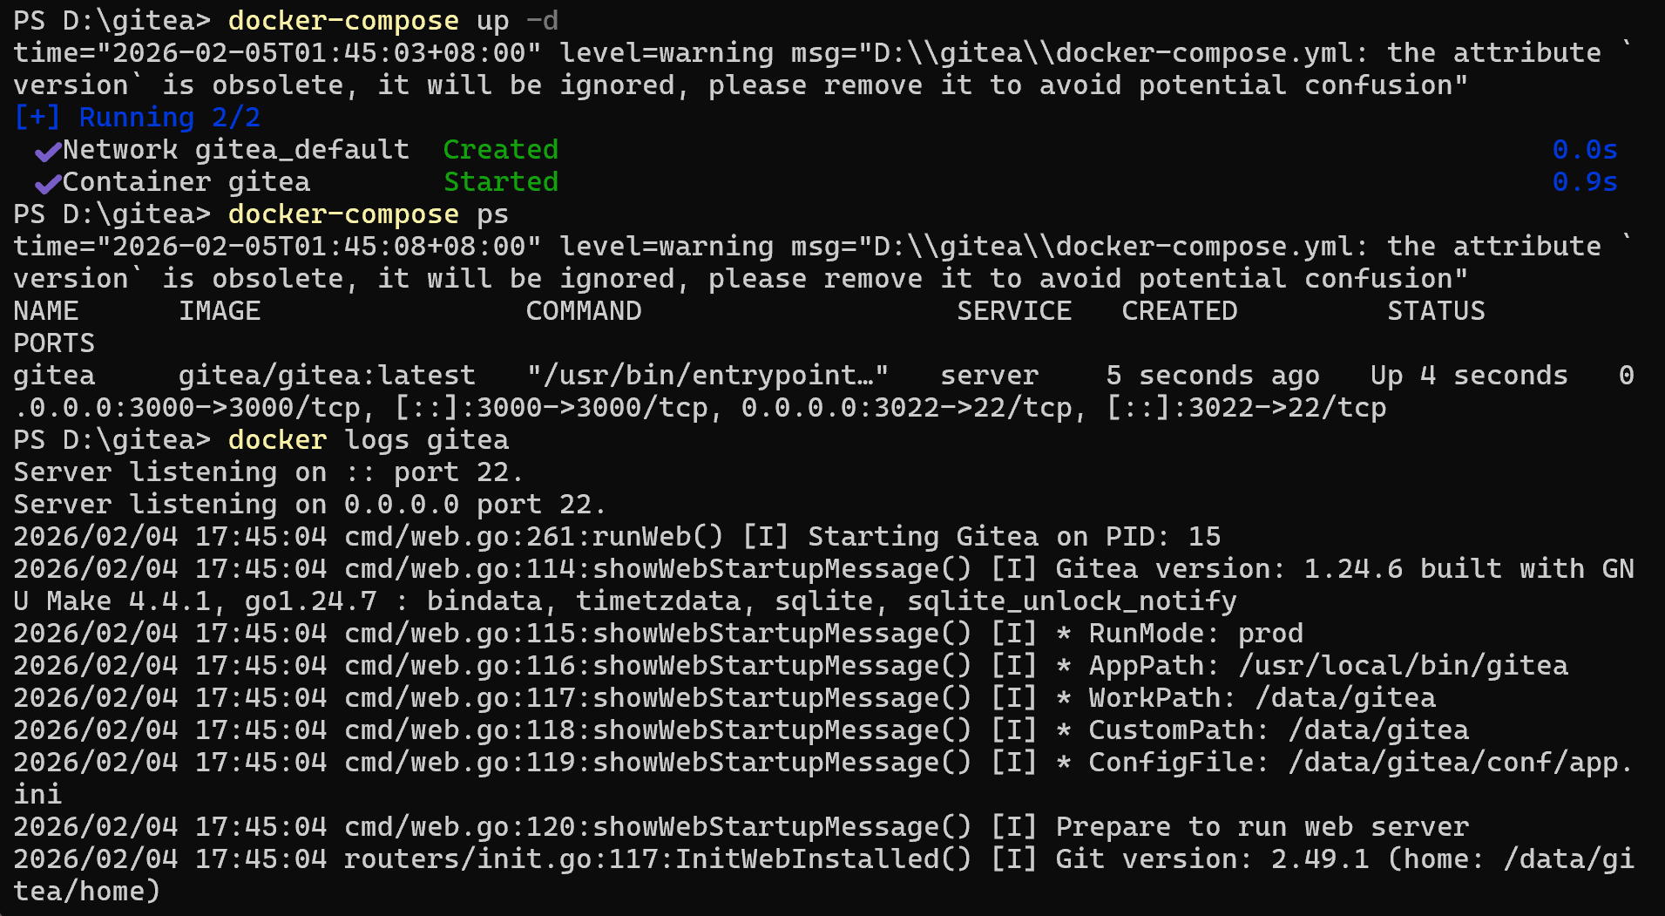
3. Initialize Gitea
（1）Open the browser and visit http://localhost:3000 to enter the Gitea installation wizard.
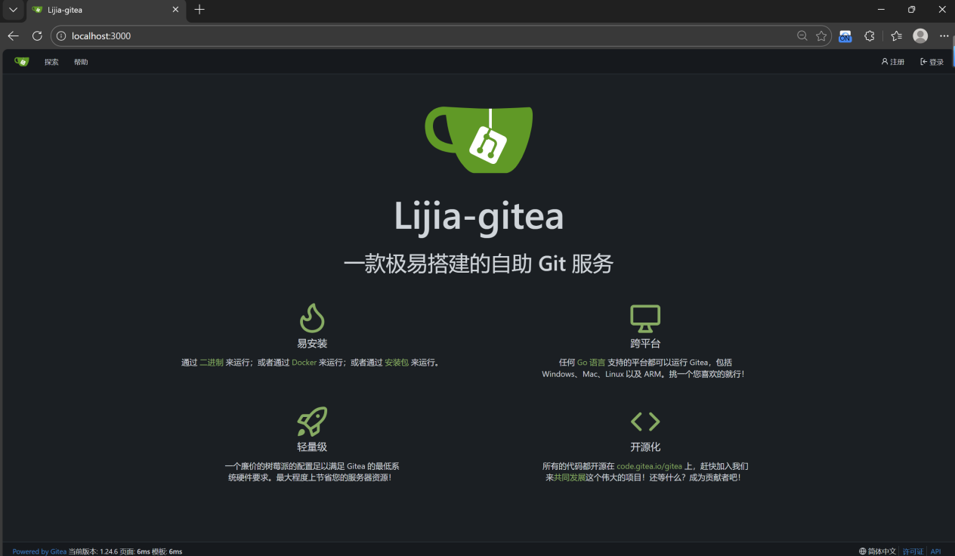

Step 4: Complete the experiment requirements
1. Verify that Gitea supports LFS
2. Create a repository containing a 1GB file
(1)create a repository “lager-file-repo”
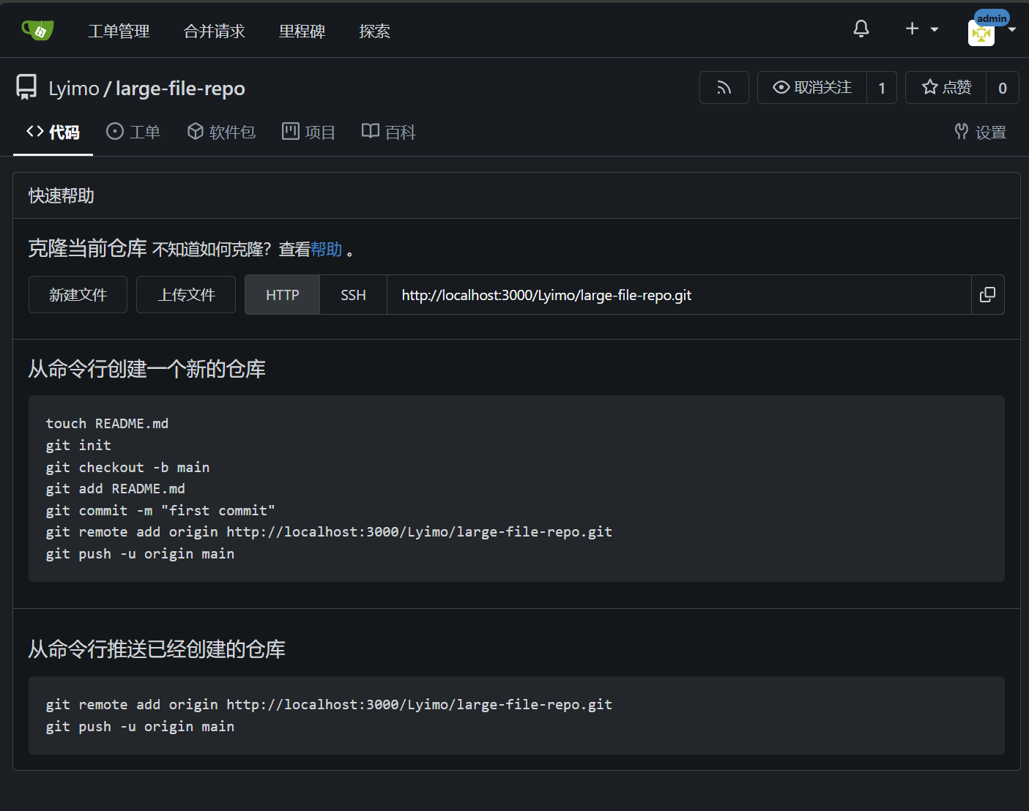
(2)Locally create 1G + test file
- install Git LFS
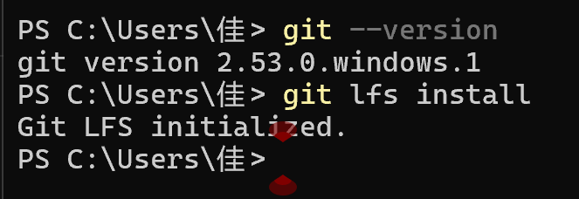
- Clone local repository
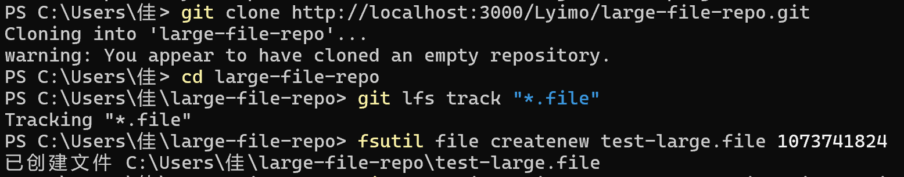
- Track large files
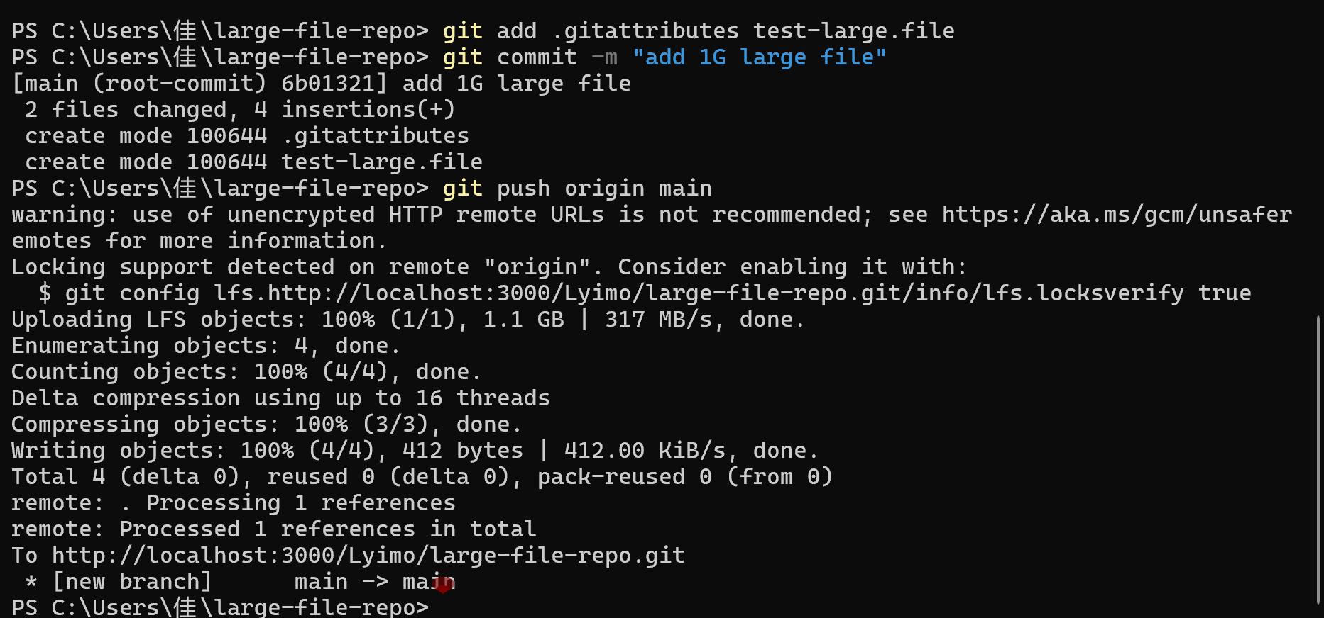
(6)Commit and push
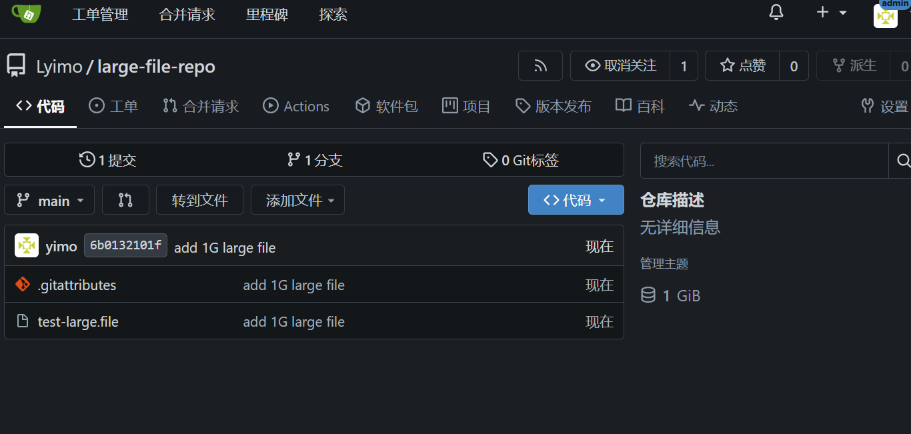
3.Create a course module repository and submit assignments
(1)Click "+" in the upper right corner of Gitea → "Create New Repository", name it lab4-module-repo, and clone it to the local area after creation.
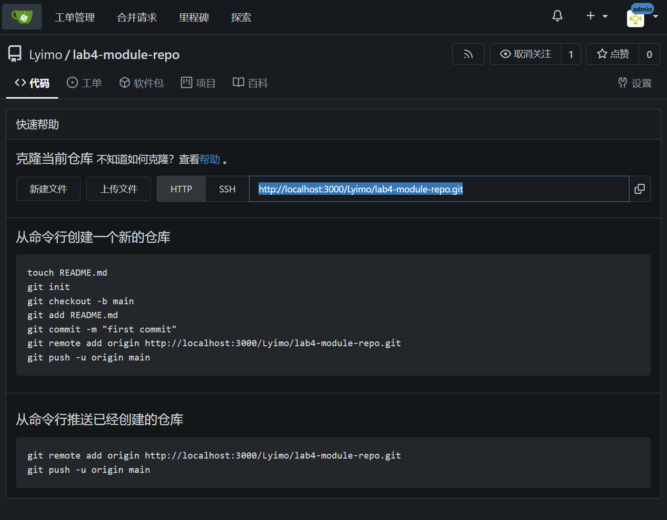
- File files such as screenshots and operation records of experimental steps into the repository directory.
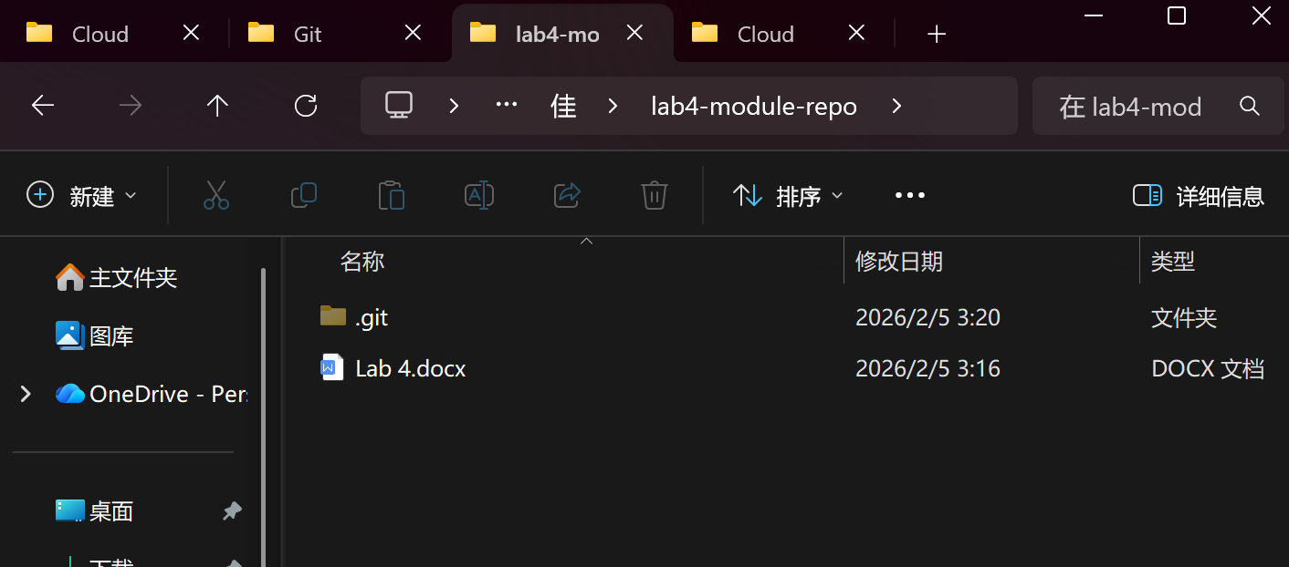
(3)Run git add .→git commit -m "submit lab4 work"→git push origin main, complete the commit, and keep the screenshot.
